B’TECH PROJECT REPORT

On

EMAIL SPAM DETECTION USING ML TECHNIQUES

By

**Karlapudi Guru Mahesh (12012033)**

**Under the Supervision Of**

**Mr. Santosh Kumar Sir, Assistant Professor**.



## Department Of Computer Engineering

### National Institute of Technology, Kurukshetra.



CERTIFICATE

This is to certify that the project report entitled “EMAIL SPAM DETECTION USING ML TECNIQUES” submitted to the Department of Computer Science and Engineering, NIT Kurukshetra, in partial fulfillment for the award of the degree of Bachelor of Technology in Computer Science and Engineering, is a record of bona fide work carried out by Mr. Karlapudi Guru Mahesh, Roll No. 12012033, under my supervision and guidance.

All help received by him from various sources have been duly acknowledged.

No part of this report has been submitted elsewhere for award of any other degree.

Signature of supervisor:

(**Mr. Santosh Kumar)**

***Table of contents***

|  |  |
| --- | --- |
| **Topic** | Page no |
| ***Abstract*** | ***4*** |
| ***Introduction*** | ***4 - 5*** |
| ***Motivation*** | ***5 - 6*** |
| ***Literature review*** | ***6 - 7*** |
| ***Methods & Materials*** | ***7 - 13*** |
| ***Algorithms*** | ***13 - 14*** |
| ***Implementation*** | ***14 - 22*** |
| ***Result*** | ***22 - 23*** |
| ***Conclusion*** | ***24*** |
| ***Reference*** | ***24 - 25*** |

***Abstract:***

Email spam is one of the greatest threats to the modern web, and several anti-spam systems have been developed to combat this threat. The main difficulty with these classifiers is predicting keywords for emails in personalized inboxes. These spam emails can also lead to the leakage of important data. Researchers today take advantage of various aesthetic features of email messages to mark them as junk or junk. Email spam detection can be greatly impacted by the use of recognized words, phrases, acronyms, and idioms. The purpose of this study is to validate a number of methods for classifying various datasets from previous research efforts and to evaluate them based on their recall, accuracy and precision. Contrasts between traditional ML techniques were noted. Typically, most of this type of communication is commercial in nature. However, often such emails can contain bogus links that cause infection. Therefore, careful strategies should be put in place to detect or isolate such garbage communication so that it can save significant computational effort and memory. In this study, we developed an NLP approach that can distinguish between fraudulent and non-junk emails before classifying them into different types of spam. Our preferred method generates vocabularies and attributes for best results and learns them using machine learning techniques.

1. ***Introduction:***

E-mail or advanced mail phishing is characterized as "the utilize of e-mail to convey spontaneous communications or commercial messages to a gather of beneficiaries." Spam implies that the beneficiary has not agreed to get such emails. "The utilize of spam emails is getting to be increasingly common." 10 years. Extortion may be a enormous issue on the Web. Spam is an mishandle of disk space, exertion and speed. Consequently sifting e-mail may eventually be the foremost successful approach to spam detection, but for presently spammers can quickly and effectively bypass such spam channel apps. Until a number of a long time prior, you may physically square much of the spam from particular mail addresses. Distinguish spam employing a machine learning approach. Essential e-mail sifting strategies incorporate "content investigation," space title whitelists and boycotts, and network-oriented methods. "Content investigation of mail information may be a prevalent approach to combat spam. There are numerous answers on the system and buyer portion. Credulous Bayes techniques are the foremost commonly utilized in these operations. Calculations, but basically message-based dismissal, substance rating encompasses a huge issue when it comes to wrong positives, more often than not buyers and businesses do not have to be lose genuine intelligent. Boycott strategies were likely the to begin with procedure utilized to dispense with spam. The methodology is to recognize all entries but those inside the realm/email id. certainly boycotted. As more locales drop into the spammer ID category, this approach will no longer work. A white record address is the title of a website related with an progressively insignificant quiet holding up list, easily accepted and most likely after the sender reacts to her ask for security sent by "e-mail". It contains a huge impact.

Machine learning strategies are more viable since they utilize preparing tests, which are sets of emails that have as of now been categorised. There are a few strategies accessible in machine learning methods which will be used for e-mail screening. "Naive Bayes, support vector machine, neural systems, K-nearest neighbor, irregular woodland models, etc." are a few of these strategies.

1. ***Motivation:***

One of the foremost imperative shapes of communication these days is mail. All inclusive, 4.1 billion e-mail accounts are anticipated to exist in 2014, and more than 196 billion emails are sent every day. One of the most dangers that e-mail clients confront is spam. Spam made up 69.6% of all mail activity in 2013. Shoppers may take after joins in spam emails to phishing or malware-infected websites, which might get to and harm the recipient's computer framework. These websites seem moreover get critical information from them. Furthermore, spam brings down efficiency, which costs businesses around $2000 per representative annually. As a result, an viable spam sifting framework is basic to the long-term practicality of the web and of our society.

There are as of now a few strategies for recognizing spam. These strategies incorporate content-based screening, greylisting, perceiving bulk emails, scanning message headers, and blacklisting:

Boycotting may be a procedure for distinguishing IP addresses that send a part of spam. Future emails from the IP addresses on the list are rejected, and these IP addresses are included to a space title system-based blackhole list. Spammers are maintaining a strategic distance from these records by utilizing more IP addresses, all things considered.

Another strategy of identifying bulk emails is to screen them for spam. When deciding whether it a message is fraudulent or not, this strategy takes the number of beneficiaries into consideration. In any case, a part of legitimate emails may get a parcel of activity.

In arrange to discover spam, one sensible strategy is to filter message headers. Spammers utilize program to develop e-mail headers. These headers in some cases incorporate mistakes that avoid them from following to standard heading details. When these features incorporate typos, it serves as a ruddy hail that the mail may be spam. Be that as it may, spammers are getting to be more capable at learning from their botches and making comparable blunders less frequently.

Greylisting is the hone of dismissing emails and returning them with an mistake take note to the sender. Individuals are more likely to resend the email than spam programs, which is able ignore this and not do so. Be that as it may, this approach bothers people and isn't the finest choice.

To extend viability, current spam techniques could be combined with content-based spam sifting innovation. In arrange to identify whether an mail is spam, content-based methods assess the email's substance. Our study's objective was to assess machine learning algorithms' viability as content-based spam filters.

1. ***Literature Review:***

The creators of the article[1] have highlighted a few variables related to mail headers that can be utilized to successfully identify and classify spam communications. These characteristics were chosen for their esteem in distinguishing spam writings. This consider too compared all the highlights advertised by Hotmail, Gmail and Yahoo mail so that it can give a common spam discovery strategy for all major mail benefit suppliers. Within the paper [2], a unused methodology based on the concept of sentence redundancy recurrence has been put into hone. To decide the closeness of gotten emails, key expressions - key expressions - of approaching emails must to begin with be labeled. Another, the grammatical work of the complete word within the sentence must be decided. Emails gotten are classified utilizing the K-Mean strategy. The method utilized to choose which category an mail has a place to is known as vector assurance. The creators of the paper [3] talked around cyber assaults. Scammers and malevolent assailants frequently utilize informing administrations to send fake communications that can fetched target clients cash and social status. These lead to the collection of individual data counting passwords, credit card numbers and other imperative subtle elements. The creators of this ponder utilized Bayesian classification. Think around each word of the letter. continually adjusting to unused sorts of spam. The approach proposed within the article[4] points to utilize machine learning methods to distinguish designs of rehashed expressions that are considered spam. This strategy also provides the capacity to classify emails based on a few other parts of their structure, such as headers, spaces, and Cc/Bcc areas. Applying each parameter to a machine learning calculation will treat it as a include. The input instrument makes a difference the machine learning demonstrate to recognize between genuine yields and vague yields after being pre-trained. This approach proposes another architecture that can be used to form spam channels. This article moreover examines the substance of emails that contain commonly utilized terms and accentuation marks.

1. ***Methods & Materials:***

This section talks about the strategy of using Natural Language Processing (NLP) to identify Spam & Ham emails based on spam collection. We start by moving, preprocessing, and splitting datasets to meet the needs of basic cognitive in computing. Separate models are then built and tested, with execution pointers used to evaluate and analyze them.

4.1 Framework:

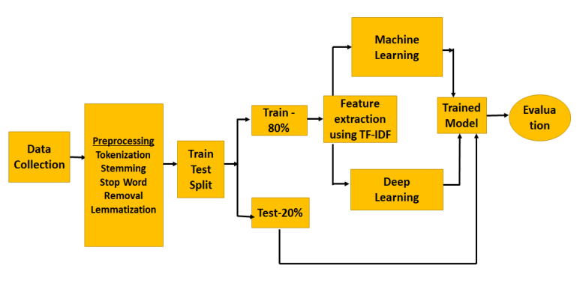

* + 1. **Dataset Collection:**

This exhibit makes utilize of a few bespoke information sets in expansion to mail information sets from a assortment of online assets, counting as Kaggle & Sklearn. Our introduction is made employing a spam e-mail information set from Kaggle, but we use extra e-mail information sources to drive the results. The spam.csv database is composed of five columns and 5572 lines.

* + 1. **Data Pre-processing:**

Pre-processing is essential to convert destitute quality information into high quality information that will be utilized in numerous applications. Since they have no bearing on word taking care of, emphasize marks, numerals, and abnormal characters are expelled amid pre-processing.  This step is necessary to prepare the text for evaluation, simulation and prediction. Pre-processing includes using natural language processing (NLP) techniques such as text tokenization, lowercase English, Stopword removal, stemming, and lemmatization. Use a porter stamp device to unstitch.

1. Stop Words :

Stopwords are English words that do not altogether contribute to a sentence's meaning. They may be securely ignored without influencing the sentence's meaning.

1. Tokenization:

Tokenization is the method of breaking down a report stream into tokens, which may be words, expressions, images, or other expressive components. Furthermore, the list of tokens is utilized to supply extra dealing with, such as substance mining and parsing. In computer program designing and improvement, tokenization is accommodating for semantics (as content separation) and lexical review.

In some cases it may be challenging to characterize what the term "word" truly implies. At the word level, tokenization takes put. A token regularly employments basic heuristics, such as: Whitespace characters like "line break" or "space" or "punctuation characters" are utilized to partitioned tokens. Each adjoining bunch of alphanumeric characters, a bit like each bunch of digits, makes up one token.

1. Bag Of Words:

A procedure for extricating characteristics from content writings is called Sack of Words (SOW). These characteristics may too be utilized to prepare machine learning frameworks. The preparing dataset's documents' special words are collected into a lexicon by means of Pack of Words.

* + 1. ***CLASSIC CLASSIFIERS:***

Information examination that employments classification extricates the models characterising critical information classes. A demonstrate or classifier is made to foresee course names.

A two-part process for classifying information might include a training phase (show building) and an identification phase.

1. NAÏVE BAYES:

The Bayesian classifier may be a as often as possible utilized probabilistic content classification strategy. A Bayesian classifier's essential objective is to distinguish whether an e-mail is spam or not by looking at which terms are there and which ones are lost from the message. Concurring to the writing, the Bayesian approach to the unused email is to select the target name that's most likely to be precise. A naïve Bayes organize is the foremost fundamental kind of Bayesian organize, in which all properties are disconnected to the esteem of the lesson variable. The categorization issue may be conceptualised as finding the equation's most extreme esteem.



P(aj) is the probability that a irregular test will have a place to category aj.P(y1, y2, y3,..., yn|aj) is the probability that category aj incorporates the include vector on the off chance that we are mindful that the preparing test has a place to that category.



The joint likelihood of all conceivable categories is P(a1, a2, a3,…..,an).

1. SUPPORT VECTOR MACHINE:

It could be a method for classifying designs. SVM works successfully with highlights that can be isolated directly and nonlinearly[12]. The challenge is to create a work that suitably classifies input characteristics whereas lessening mistake. The strategy of developing an ideal line that isolates data points into two bunches is utilized within the SVM algorithm's classification. Successive Negligible Enhancement (SNE) and a polynomial bit work have been utilized to move forward the execution of classifiers for little test learning issues.

The SVM decision making process is described as follows:



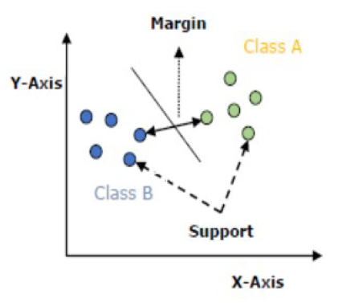

1. DECISION TREE:

The decision tree machine learning calculation is another calculation that has been utilized more frequently in directed learning strategy investigate. It can work on both category and numerical information in a framework. The decision Tree Classifier's yield is associated to a double tree, some of the time alluded to as a choice tree. A tree is made up of leaf hubs, which are utilized for categorization, and branches, each of which gives a run of conceivable outcomes to choose from. For anticipating and partner target names, it utilizes affiliations rules.

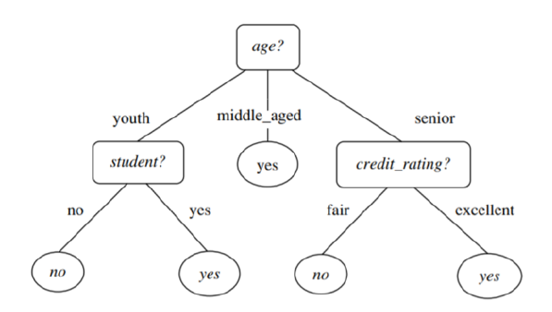

1. K-NEAREST NEIGHBOURS:

The classification strategy K-nearest neighbors.

In arrange to estimate how a unused test point will be classified, this strategy employments certain information focuses and a information vector that have been partitioned into a number of classes.

An wasteful calculation is K-Nearest Neighbor. Apathetic calculations as it were endeavor to remember the steps that they cannot learn on their claim. It doesn't make choices on its possess.

A modern point is classified utilizing the K-Nearest Neighbor strategy employing a similitude metric, which may be Euclidian remove.

The neighbors of an question are decided utilizing the Euclidean remove estimation.



***4.1.4 ENSEMBLE LEARNING APPROACH:***

Outfit strategies are a strategy in machine learning that employments numerous base models to make prescient models in arrange to decrease changeability by diminishing predisposition by boosting forecasts by stacking. Two Sorts Base classifiers are made consecutively in this case.

1. RANDOM FOREST CLASSIFIER:

It may be a machine learning strategy utilized to address classification and relapse issues. By blending a few classifiers, Arbitrary Woodland employments gathering learning to handle complicated issues.

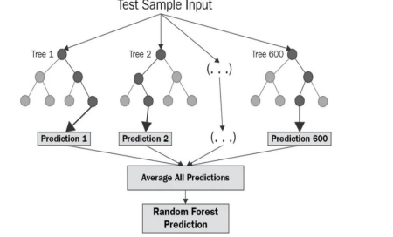

It is made up of an colossal sum of decision trees, sometimes alluded to as estimators.Every connect within the arrange is educating to use a diverse set of information to illuminate its expectations. The ultimate forecasts of the irregular timberland are hence decided by averaging the expectations of each tree.

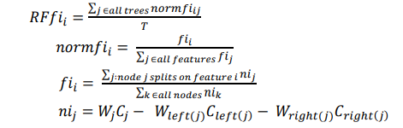

1. BAGGING:

An outfit classifier known as a stowing classifier fits base classifiers to isolated irregular subsets of the initial information sets, and after that combines each calculation (either by voting or by averaging) to deliver a last prediction.Aggregating and bootstrapping are both utilized in sacking.

Bootstrap = Sacking Amassing

By basically resampling the data from the preparing information with the same cardinality as the initial information set, bootstrapping diminishes the classifier's variance and decreases overfitting. Having a tall fluctuation is terrible for the show. Stowing may be a exceptionally proficient strategy for little sums of information, and by simply utilizing tests, you'll get an assess by averaging the comes about.

1. BOOSTING & ADABOOST CLASSIFIER:

Boosting is an outfit method utilized to combine an cluster of powerless classifiers to deliver a solid classifier. Making a show from preparing information sets taken after by building another show to redress the primary model's blemishes is how boosting is wrapped up. until the preparing set can be accurately predicted, are included within the boosting show.

AdaBoost= Versatile Boosting

The primary fruitful boosting calculation utilized for parallel classification is called AdaBoost. AdaBoost is utilized to comprehend the boosting.

1. ***ALGORITHMS:***

1.1 Embed the preparing or testing dataset or record.

1.2 Confirm the bolstered encoding within the dataset.

In case one of the perceived encodings is display, go to step 1.4.

On the off chance that one of the backed encodings isn't accessible, proceed ahead to process 1.3.

1. Switch the format of the embedded file to any among the readily accessible encodings. At that point attempt perusing one once more.

1.4. Make a choice for how you need to utilize the dataset to "Prepare," "Test," or "Compare" the models.

1.4.1 Continue to step 1.5 in the event that "Prepare" is chosen.

Go to step 1.6 in the event that "Test" is chosen in 1.4.2; to step 1.7 on the off chance that "Compare" is chosen in 1.4.3. "Prepare" was chosen:

1.5.1. Choose which classifier will be prepared with the included dataset.

1.5.2 Confirm the information for NAN values and copies.

Discover the hyperparameter tuning settings in 1.5.3.

Prepare the content for a include change in 1.5.4.

Prepare the show 1.5.5

1.5.6. Spare the characteristics and show. Show the comes about.

1.5.7. Utilizing the inputted dataset, choose which classifier to test.

Check for copies and NAN values in area 1.5.8.

1.5.9 Stack the show and highlights that were put away amid the model's preparing stage.

1.5.10. Testing the dataset using the stacked values.

1.5.11 Show the results

1.6. With "Compare" chosen:

1.6.1. Use the embedded dataset to compare each classifier.

1.6.2. Show the classifiers' discoveries.

***IMPLEMENTATION:***

The planning dataset for this module uses data collection from the 'Kaggle' website and the display is done via the Jupyter Notepad platform. Initially redundancies are verified within the supplied collection. and erroneous values ​​before the machine continues to work. The information set is subsequently divided among two smaller datasets such as his "test dataset" and "training dataset" with extent 70:30.

The "prepare" and "test" datasets are subsequently provided as word processor input variables. Highlights and terms in the stopword list will be removed during content preparation and replaced with appropriate words. The term "Featured Change" is then used using these explicit expressions. In inclusive change, the appropriate words given by the word processor are then used for "fit" and "change" to build the machine's vocabulary. In order to distinguish the best values ​​that the possible filter must employ depending on the information, the dataset is also passed for "hyperparameter tuning".

The machine is fitted employing such values in combination using a subjective state following acquiring the parameters through "hyperparameter tuning". The qualities and condition associated with the planned show are retained for utilisation for evaluating unneeded data within lengthy haul.

Such equipment’s were arranged utilizing the above-mentioned values utilizing classifiers from the Python sklearn library.

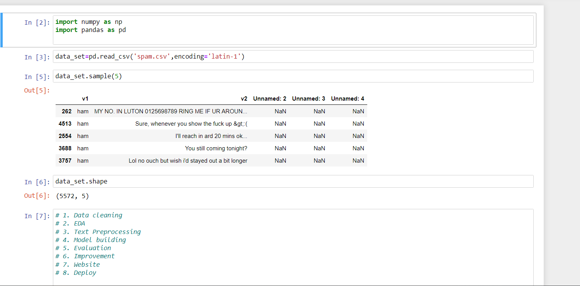

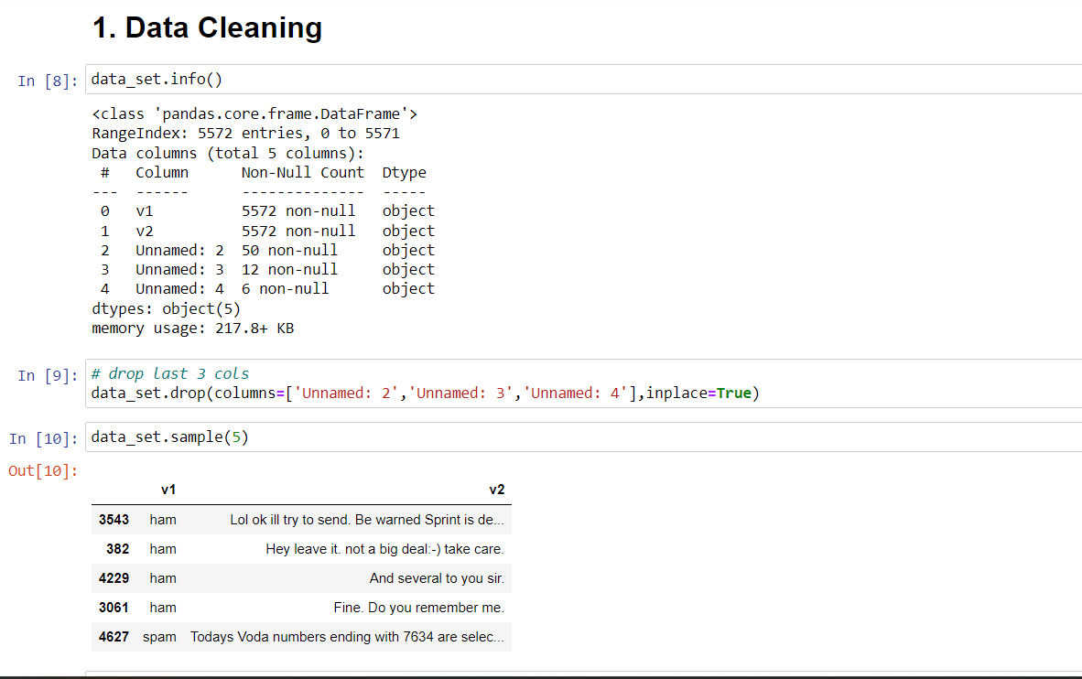

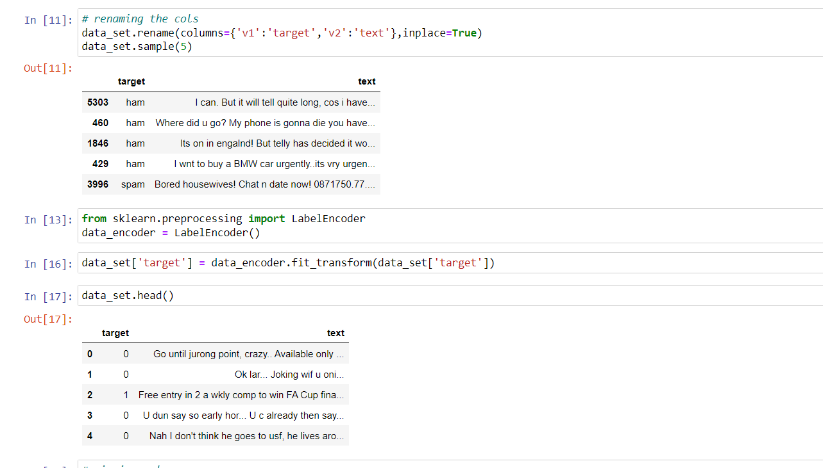

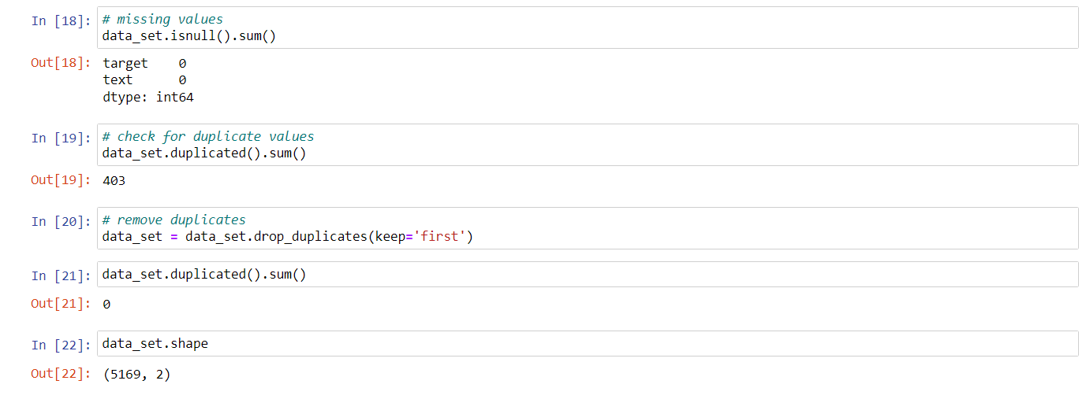

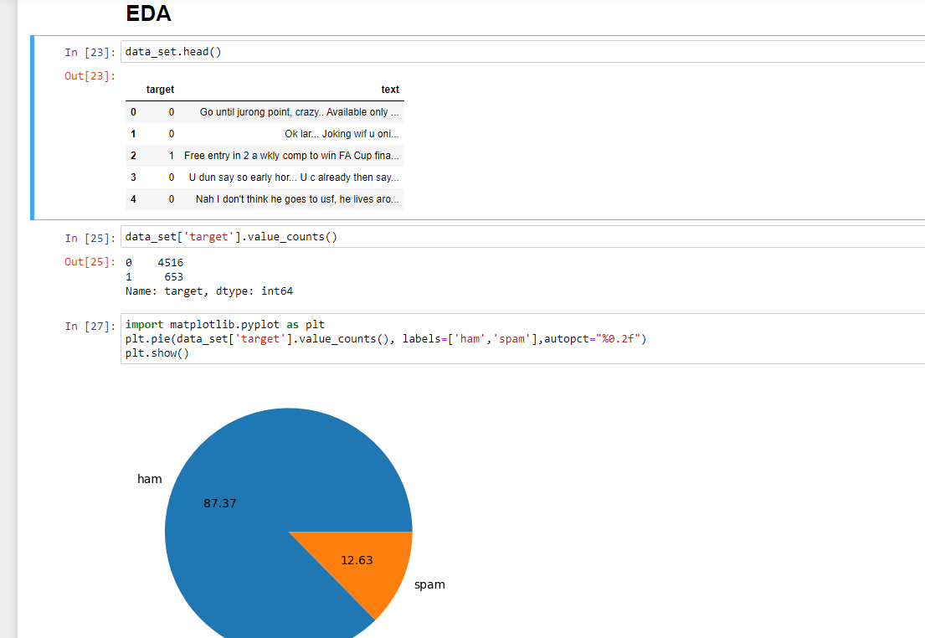

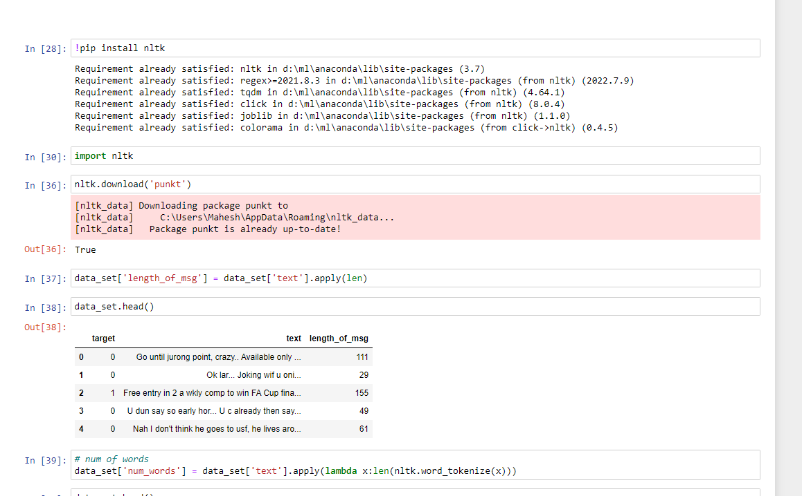

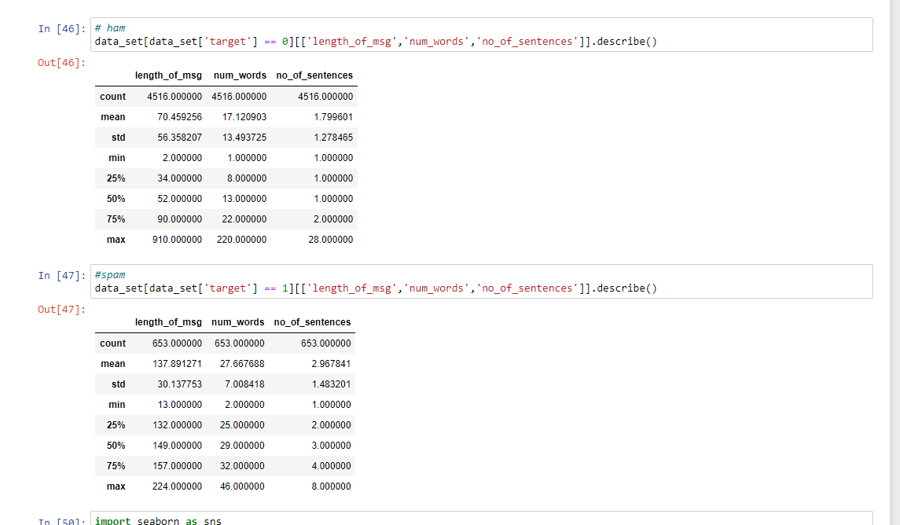

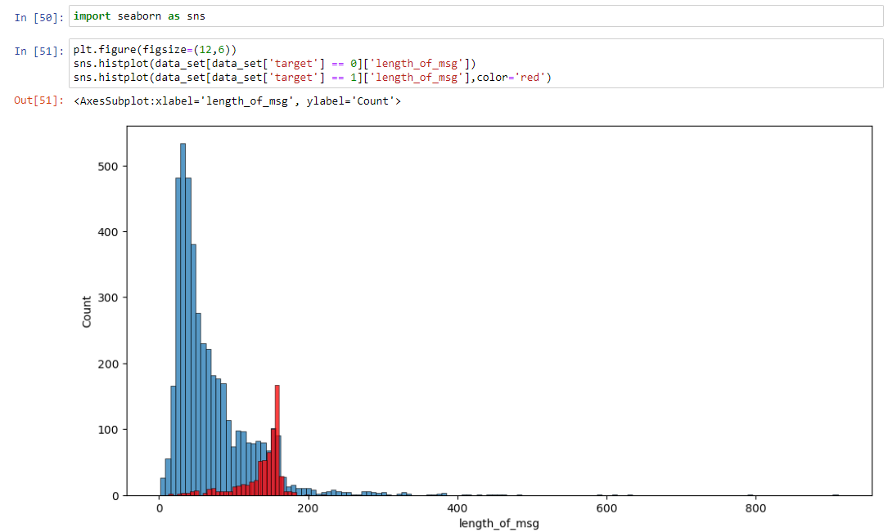

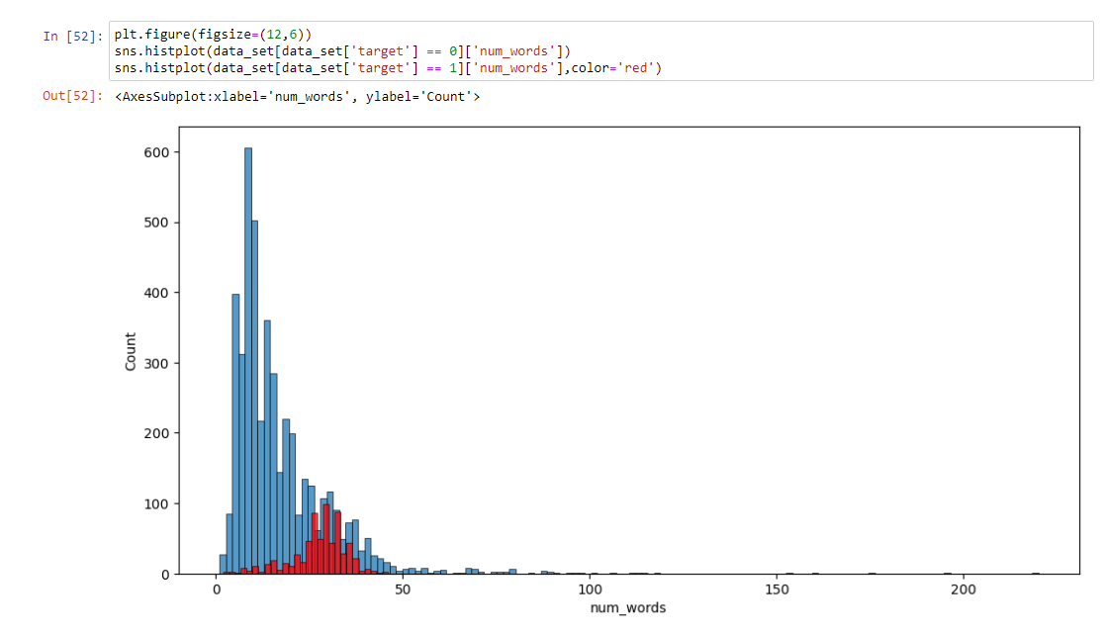

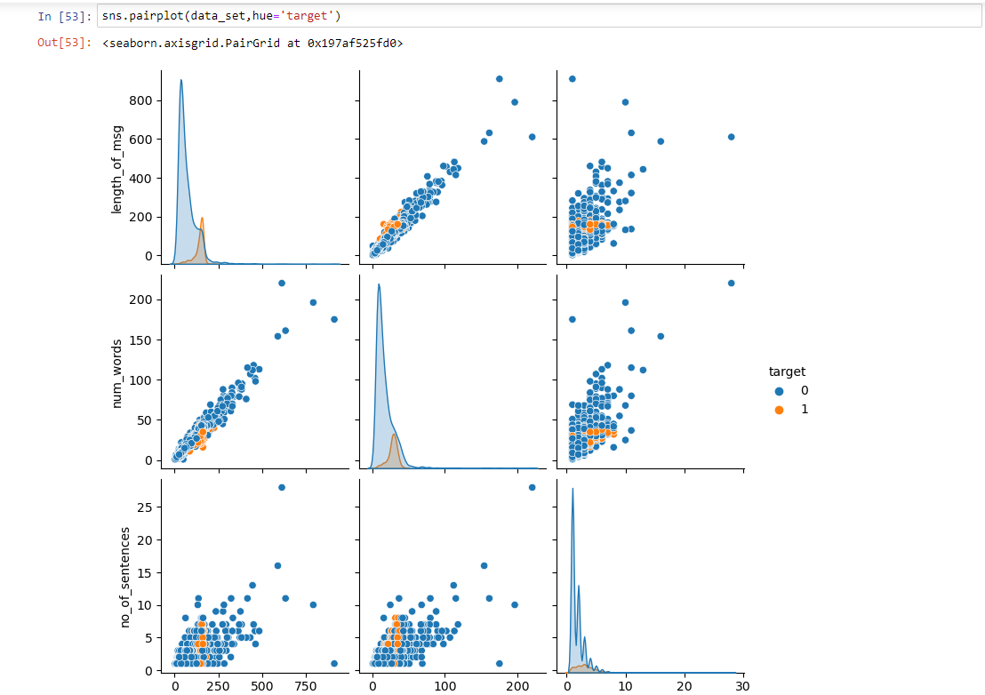

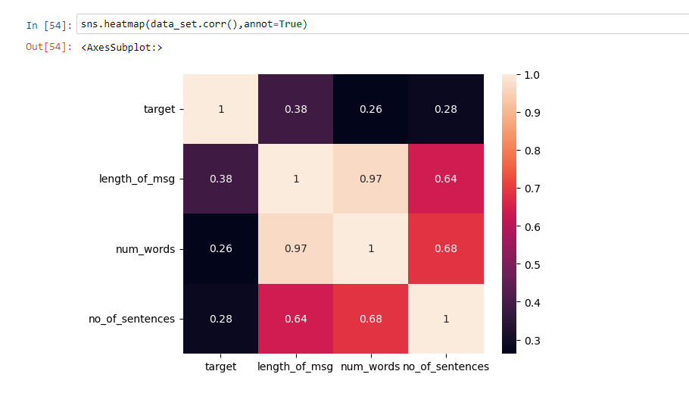

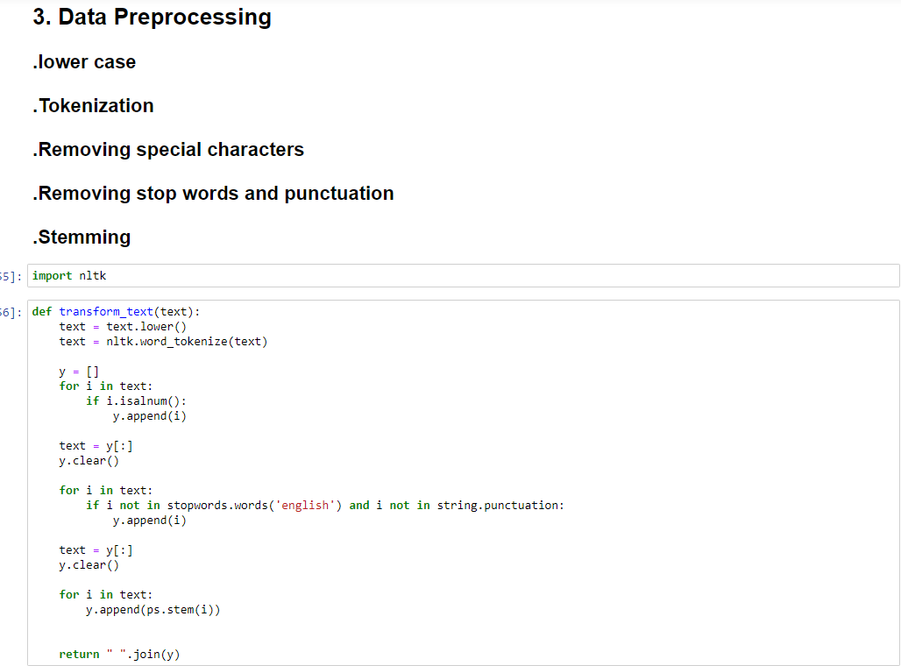

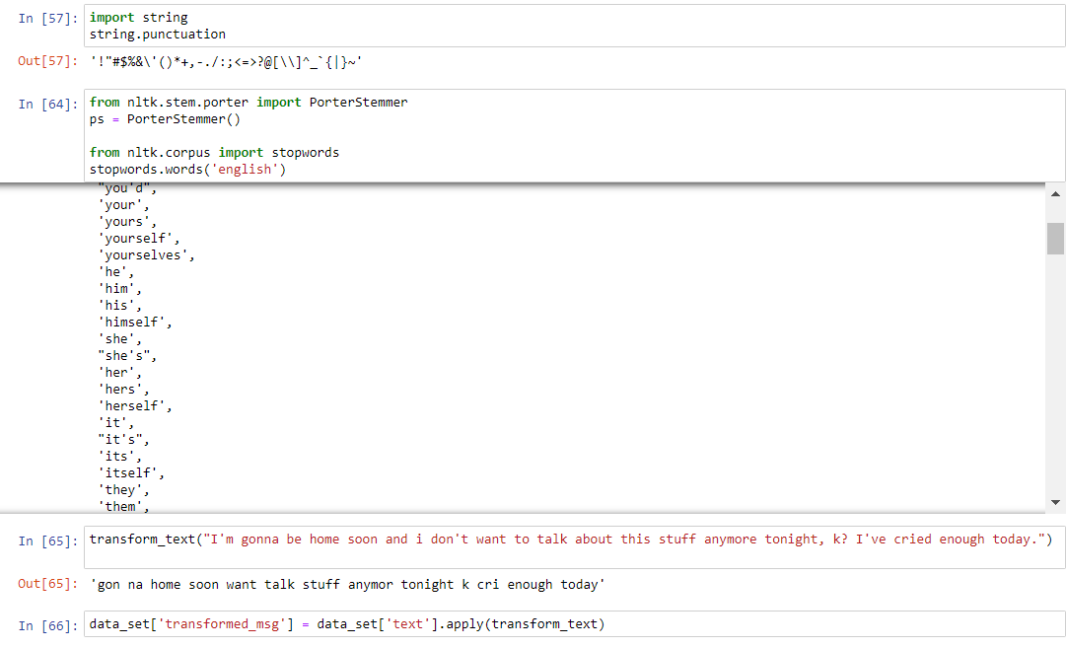

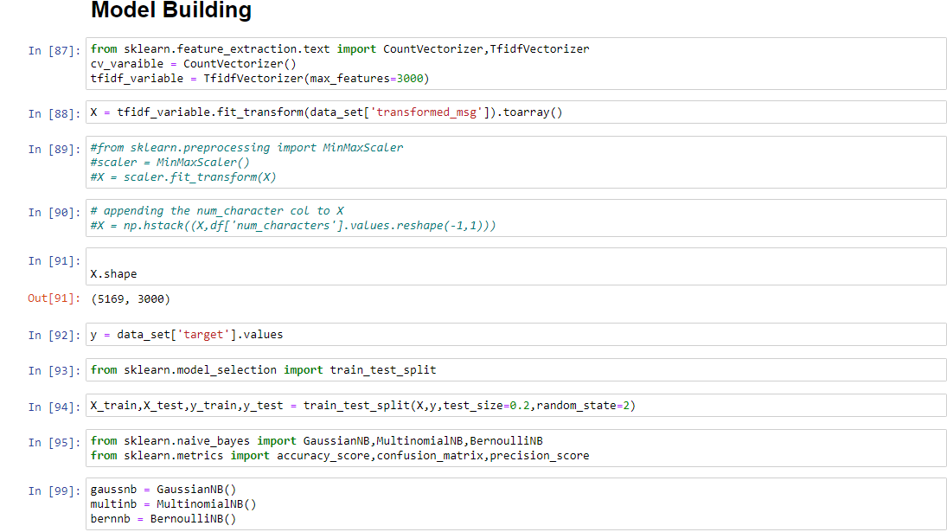

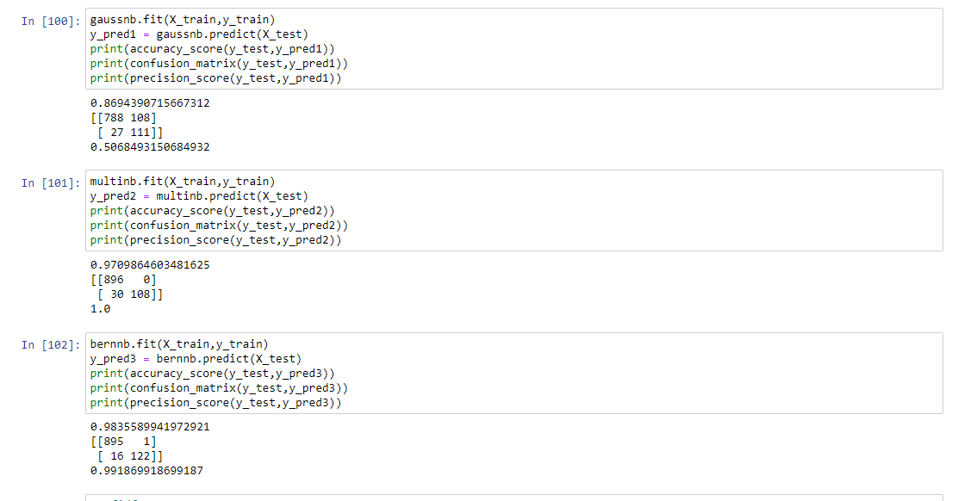

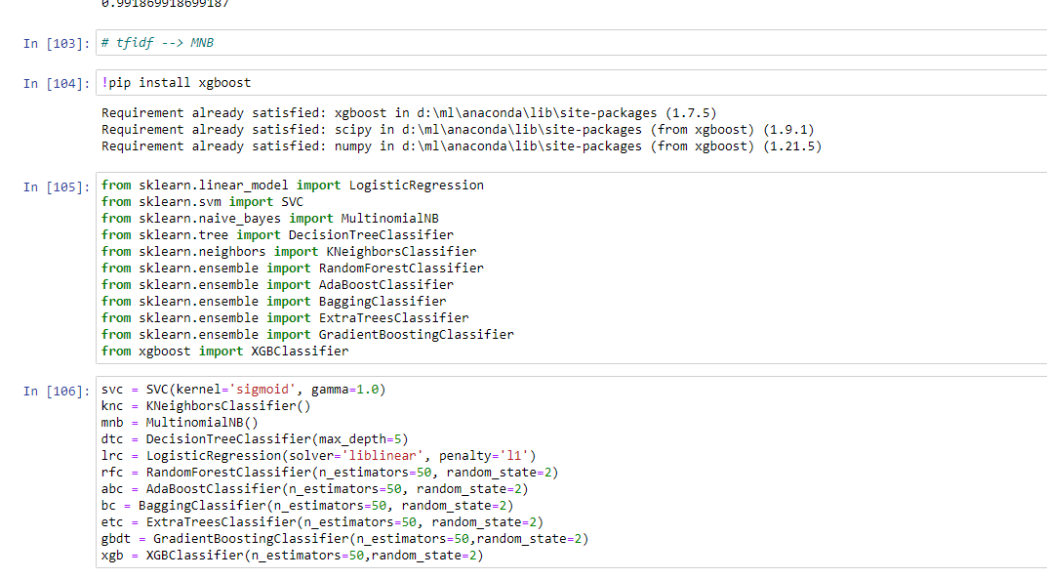

1. ***RESULT:***

To guarantee higher precision, our demonstrate was prepared utilizing numerous classifiers, which were at that point checked and compared. The client will get each classifier's evaluated comes about. The client may compare the result with other comes about to decide on the off chance that the information is "spam" or "ham" once all classifiers have returned their discoveries to them. For less demanding comprehension, charts and tables will be utilized to show each classification result. For preparing, the dataset is utilized from the "Kaggle" site. "spam.csv" is the title of the dataset that was used. The "emails.csv" CSV record, which contains information that was not used within the machine's preparing, is made particularly to test the prepared framework.

Table-1 : comparison between different algo’s

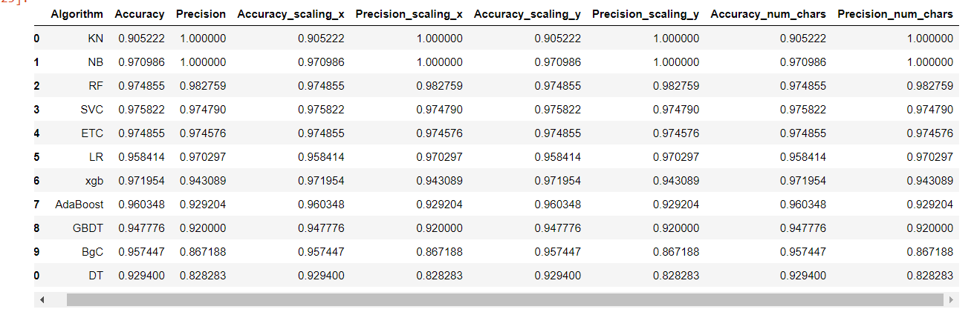

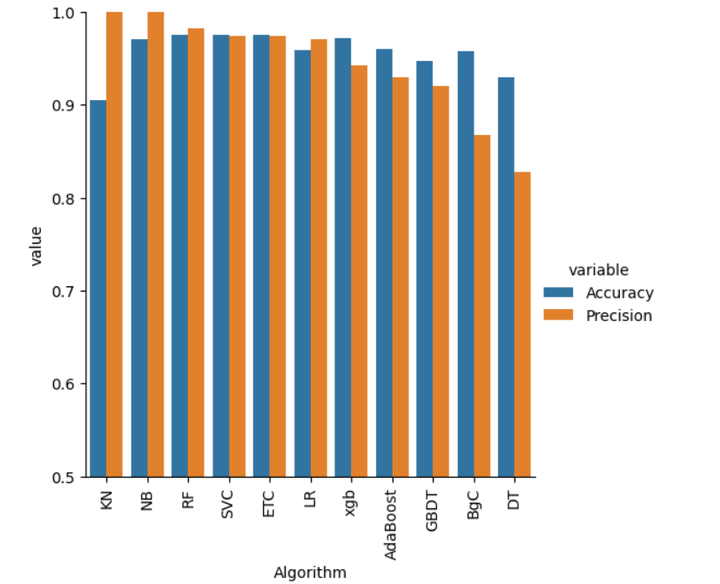

1. ***CONCLUSION:***

With this conclusion, it is obvious that the Support Vector Machine produces the most excellent comes about, but it is compelled by class-conditional autonomy, which causes it to misclassify certain tuples. On the other hand, ensemble approaches have appeared to be viable since they combine numerous classifiers to foresee classes. These days, a expansive number of emails are sent and gotten, making it challenging for our innovation to assess emails since it can as it were utilize a little corpus. Our solution, which empowers spam discovery, is able of sifting emails based on the email's substance instead of the space names or any other components.

As a result, the email's body is presently to some degree brief.

Our venture has numerous openings for enhancement. The taking after upgrades are conceivable:

On the premise of trustworthy and approved space names, spam may be sifted.

"The spam mail classification is exceptionally critical in distinguishing spam from non-spam emails and in categorising emails."

"The huge body can utilize this strategy to recognize respectable emails that are as it were the emails they need to get."

1. ***REFERENCES:***

1. Suryawanshi, Shubhangi & Goswami, Anurag & Pat il, Pramod.

(2019). Email Spam Detection: An Empirical Comparative Study of

Different ML and Ensemble Classifiers. 69-74.

10.1109/IACC48062.2019.8971582.

2. Karim, A., Azam, S., Shanmugam, B., Krishnan, K., & Alazab,

M. (2019). A Comprehensive Survey for Intelligent Spam Email

Detect ion. *IEEE Access*, *7*, 168261-168295.

[08907831]. ht tps://doi.org/10.1109/ACCESS.2019.2954791

3. K. Agarwal and T. Kumar, "Email Spam Detect ion Using

Integrated Approach of Naïve Bayes and Part icle Swarm

Opt imization," 2018 Second International Conference on Intelligent

Comput ing and Control Systems (ICICCS), Madurai, India, 2018,

pp. 685-690.

4. Harisinghaney, Anirudh, Aman Dixit , Saurabh Gupta, and Anuja

Arora. "Text and image-based spam email classificat ion using

KNN, Naïve Bayes and Reverse DBSCAN algorithm." In

Opt imization, Reliabilty, and Information Technology (ICROIT),

2014 Internat ional Conference on, pp.153-155. IEEE, 2014

5. Mohamad, Masurah, and Ali Selamat . "An evaluat ion on t he

efficiency of hybrid feature selection in spam email classificat ion."

In Computer, Communications, and Control Technology (I4CT),

2015 Internat ional Conference on, pp. 227-231. IEEE, 2015

6. Shradhanjali, P rof. T oran Verma “ E-Mail Spam Detect ion and

Classificat ion Using SVM and Feat ure Extraction”in Int ernat ional

Jouranl Of Advance Reasearch, Ideas and Innovat ion In

Technology,2017 ISSN: 2454-132X Impact factor: 4.295